THINGS TO FINALISE :
REFERECNCE AREA;
LINER LENGTH AND DIAMETER ;
INNNER COMBUSTION WALL DIAMETER
PLANNING ON MAKING THEM WITH SHEET METAL , DIMENSIONS , TO CUT , ETC .
HOLE DIAMETERS
KEY DIFFERENCES AND DESGIN CHANGES BW TURBINE LESS AND TURBINE JET ENGINES
AND INCORPORATAE IN THE DESIGN ACCORDINGLY
……………………………………………………..
AFTER A ROUGH FINALISED DESIGN ALL THE PARTS HAVE TO PLANNED ON HOW TO BE BROUGHT FROM IMAGINATION AND BRAIN TO REAL LIFE .

Energy density of fuels :
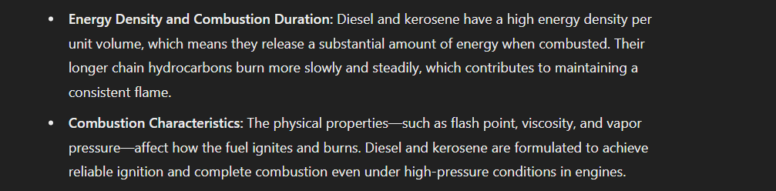

Nozzle variations
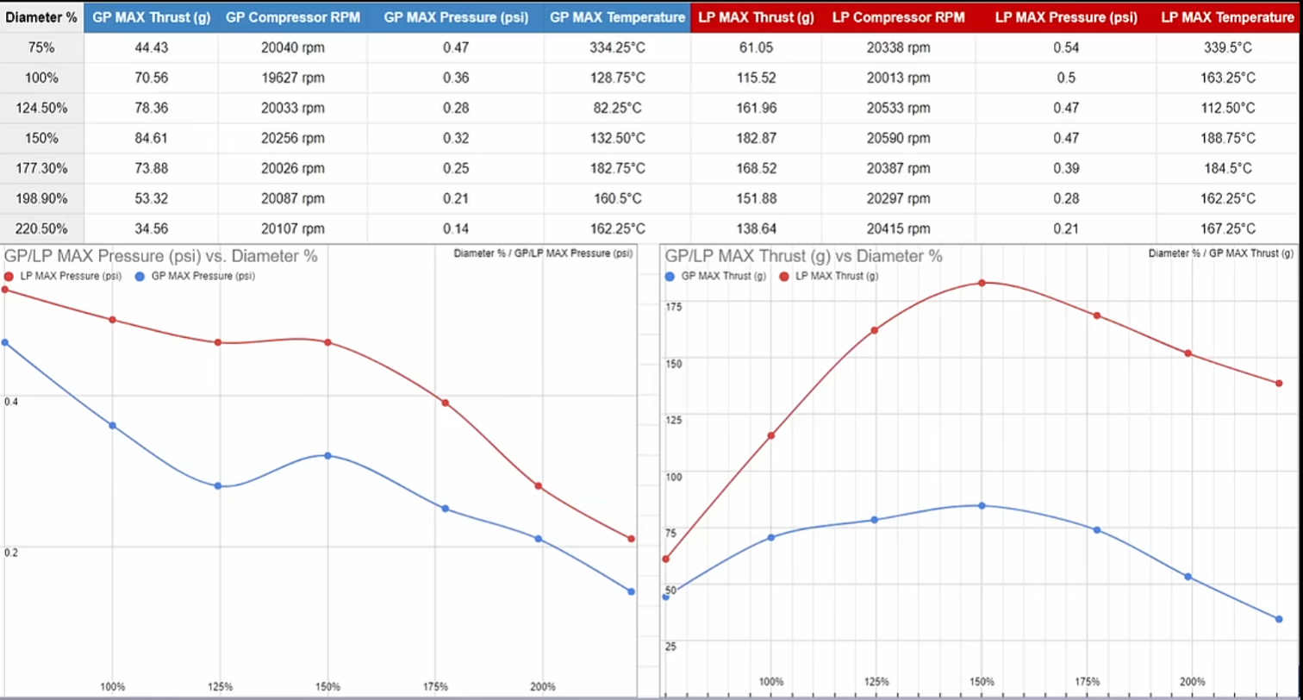

How are Russian s able to achieve a stable thrust ?
Things to buy :
1)Butane cans
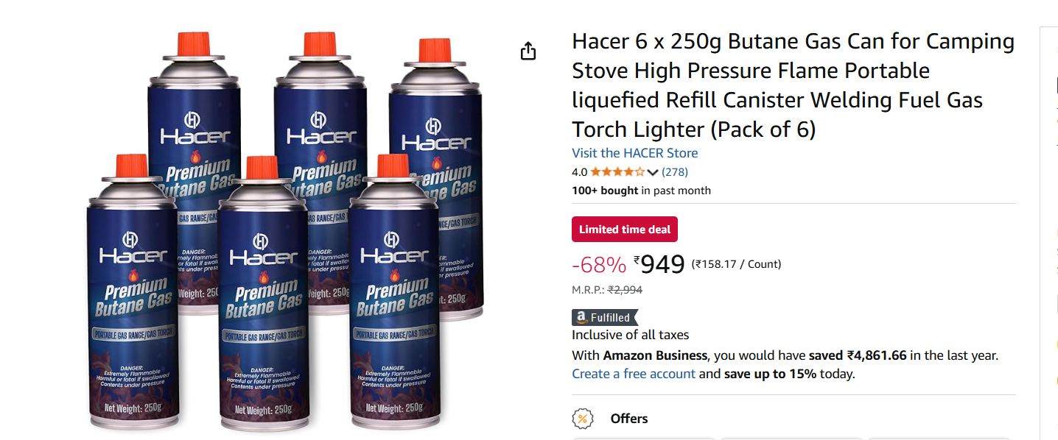
2)BRASS TORIODS , SMALL RODS
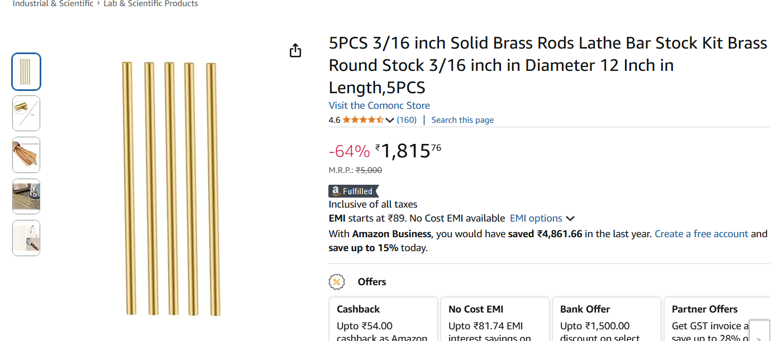
3)GLOWING CERAMIC FOR IGNITION


THINGS TO FINALISE :
REFERECNCE AREA;
LINER LENGTH AND DIAMETER ;
INNNER COMBUSTION WALL DIAMETER
HOLE DIAMETERS
KEY DIFFERENCES AND DESGIN CHANGES BW TURBINE LESS AND TURBINE JET ENGINES

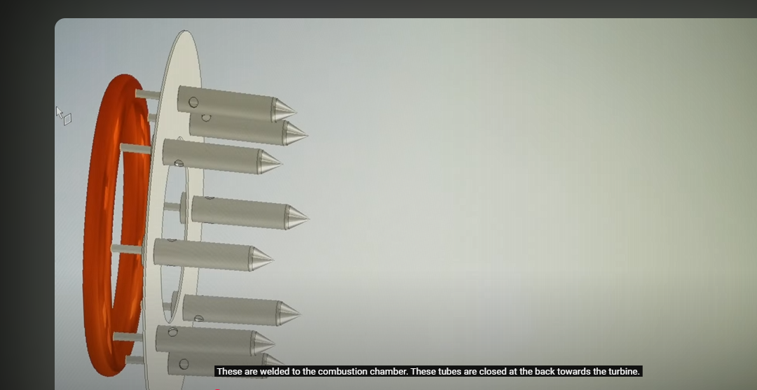
Capillary tubes closed close to turbine



A recirculation zone is a region within a flow field—such as in a jet engine’s combustion chamber—where the fluid (or gas) circulates or reverses its typical downstream direction. In combustion systems, recirculation zones are often intentionally created because they help stabilize the flame. By redirecting hot combustion products back toward the incoming fuel-air mixture, these zones promote better mixing, enhance ignition, and ensure a more uniform and efficient combustion process.
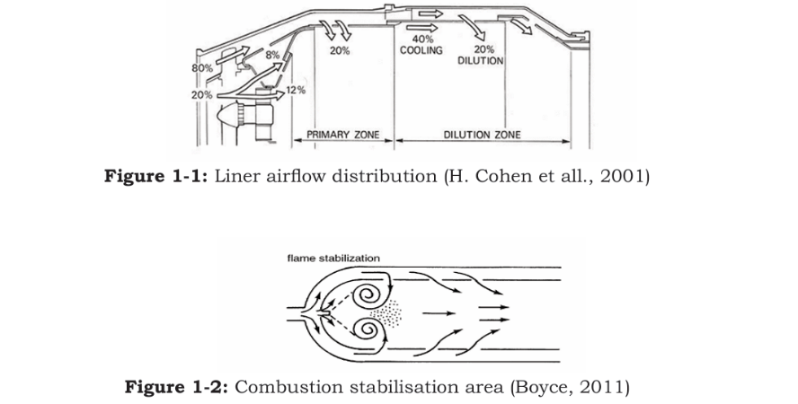
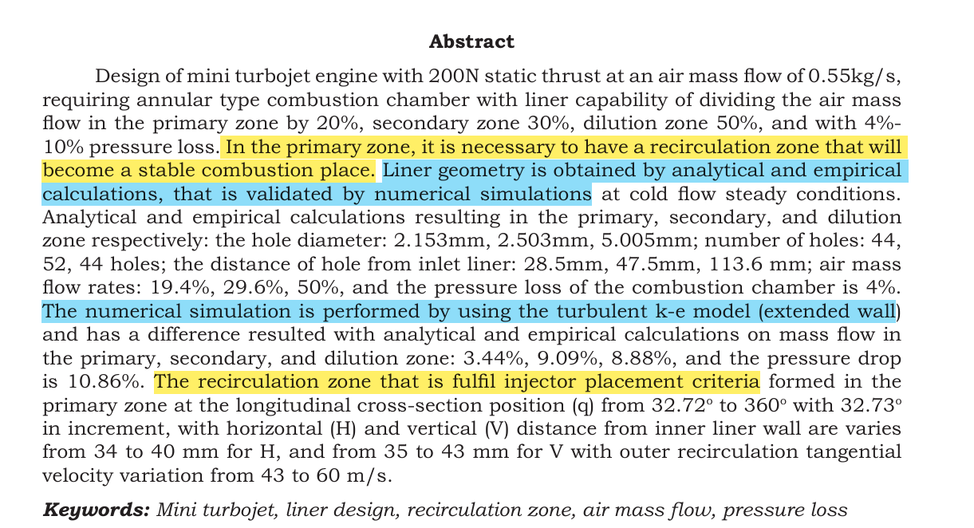
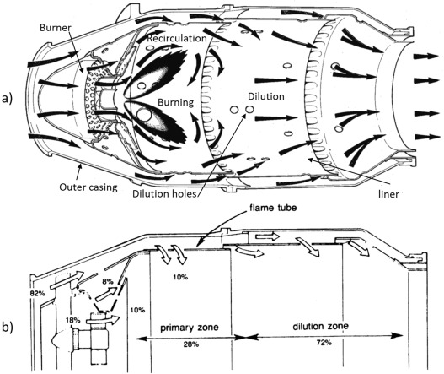

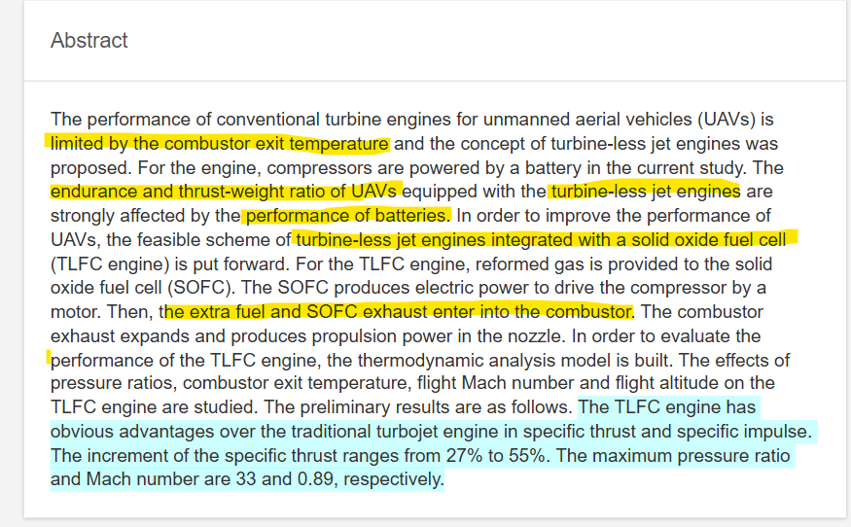
https://www.researchgate.net/publication/334303008_Thermodynamic_Performance_Evaluation_of_a_Turbine-less_Jet_Engine_Integrated_with_Solid_Oxide_Fuel_Cells_for_Unmanned_Aerial_Vehicles

Some appears closed to combustion chamber but they are , just vanes changing the direction of flow ,
The tube which is part of fuel injector has air fuel mixture , propelled forward by air coming from behind with pressure from in the combustion chamber ,so the fuel ring can either be in front or behind the combustion chamber .And the thin pipe form the ring is less prone for stagnation of heat as gases travel outside and away from the thin pipe .

https://youtu.be/6RWbzGIaUG0?si=rYrALir_bcIQP8f7
just another detailed explanation of jet engine with cad model .

4/1/25 damn its 2025
Reference cad models
https://grabcad.com/library/kj66-turbine-combustion-chamber
https://grabcad.com/library/kj66-complete-turbine-engine
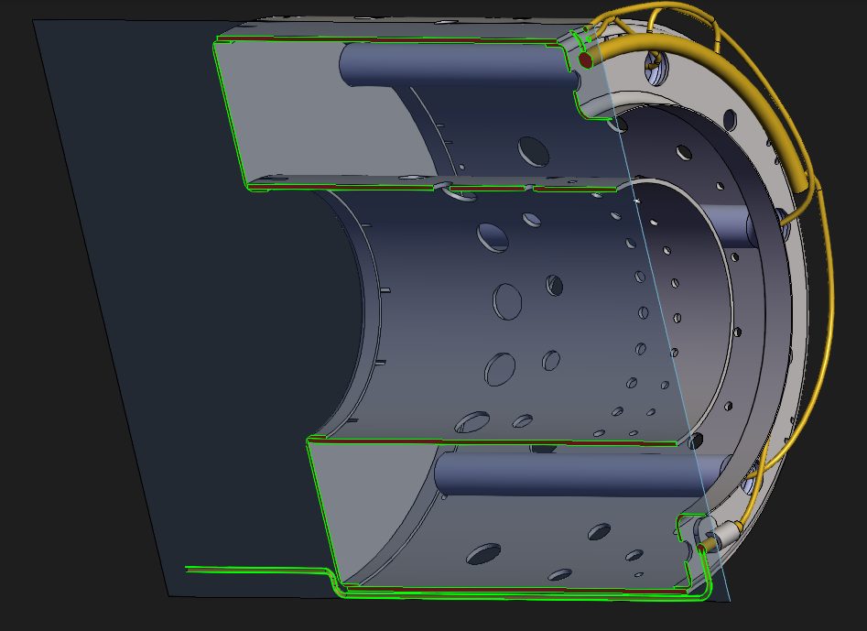
`1`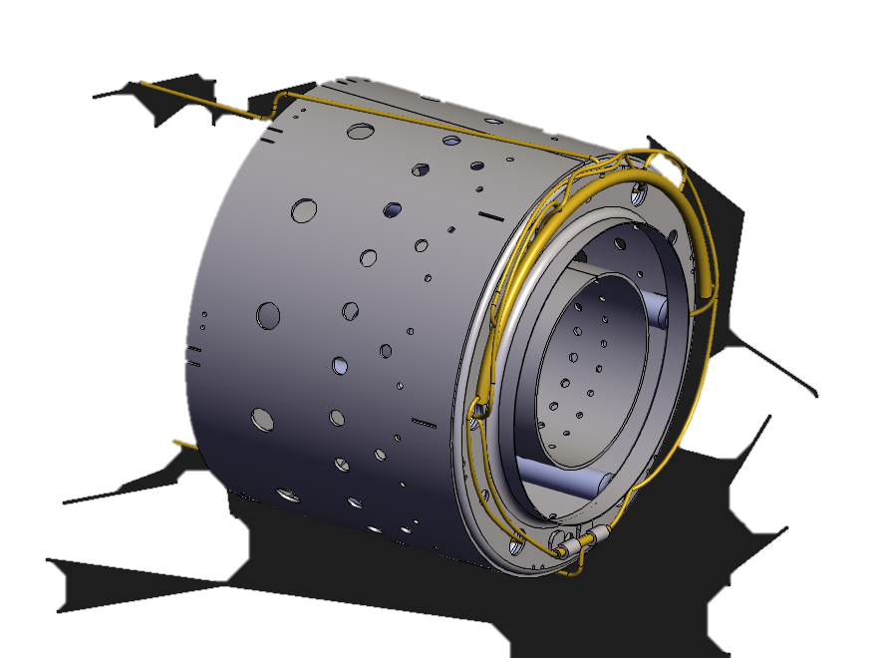

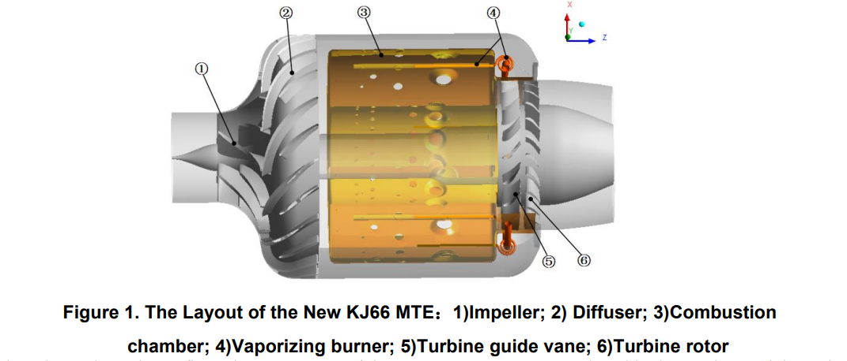

Clear picture of fuel injection

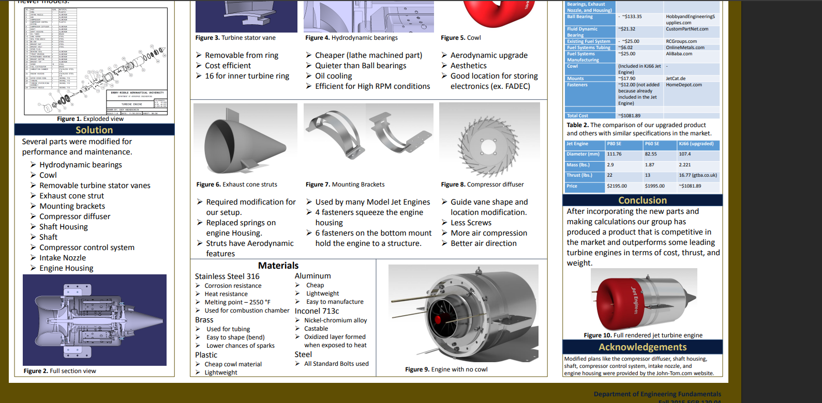materials for jet engine and for kj 66 jet engine _
https://commons.erau.edu/cgi/viewcontent.cgi?article=1027&context=asee-edgd

Continued above ……….)for the return mentioned in the last page(

Jet engine models Grab cad
https://grabcad.com/library/turbine-engine-tk-50-1
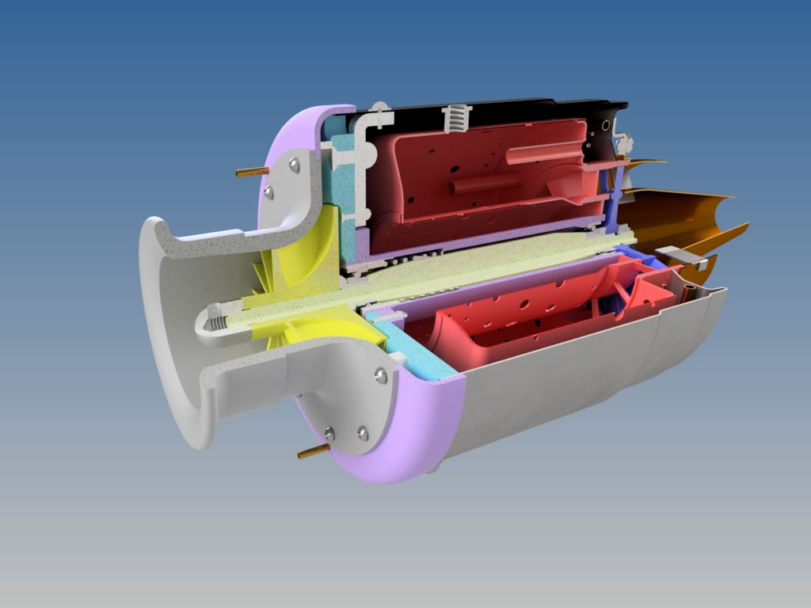 https://grabcad.com/library/turbine-engine-kj-66-1 design 3(compresser diffuser behind and diverging nozzle to be added)
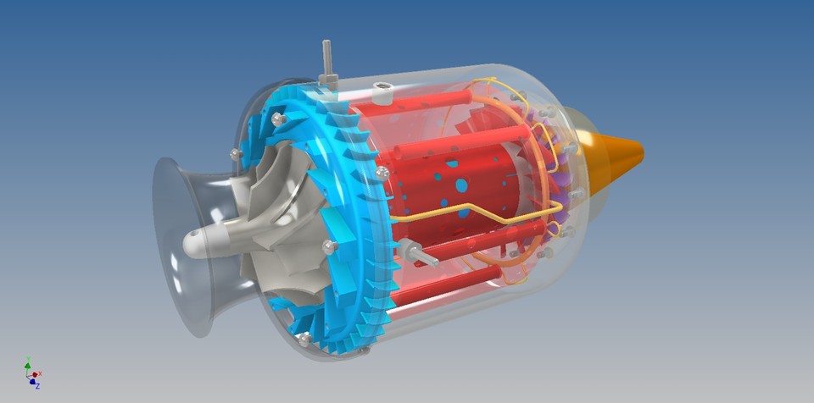
Images : (design 3 a similar oe )
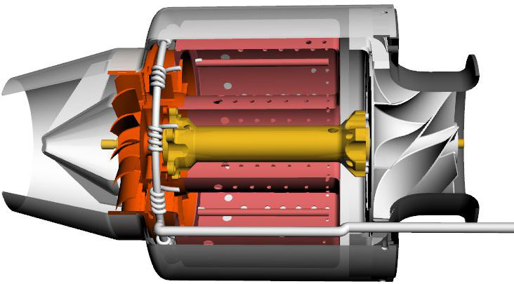
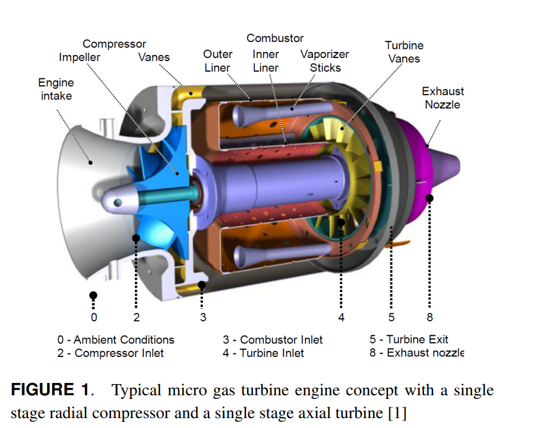
Design 1 just the diverging nozzle , no holes in from of the combustion chamber .

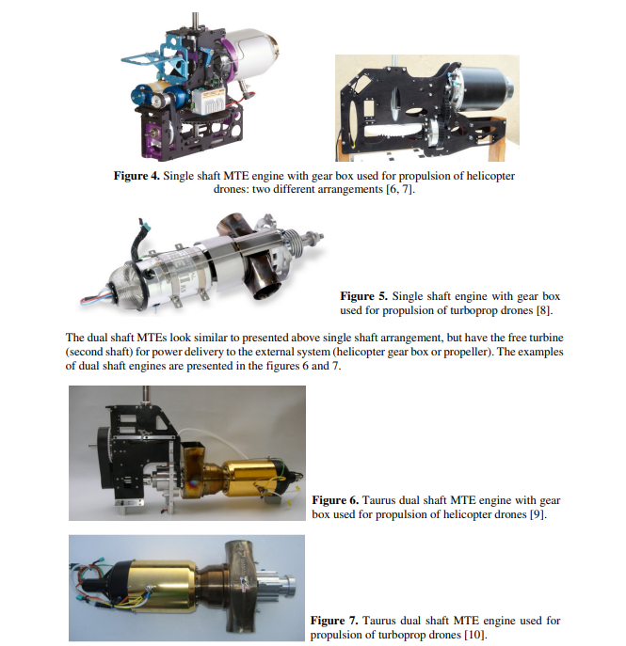
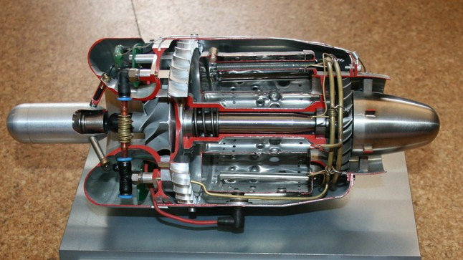
using gear box

Where I am stuck is,
I finalized to use just the diffuser, and no converging behind the impeller due to several complications of it like
Disadvantages of it
increased complexity ,
decreased size and mass flow through it , etc .

I feel like there is intense heat concentration there , if I put a diffuser behind the impeller that does not seem practical ..
So instead to get the same increase in pressure , I’ll put a diffuser section behind the compressor’s diffuser and
So the order is
Impeller Compresser Diffuser combustion chamber diffuser
So the previously though thing is that .
I intutiveky felt that holes in front of the combustion chamber ,would be better ,
So this can be achieved through
Even we let the air passage upwards small holes can be made in front of the combustion chamber and , small gaps between the air passage can allow the air to flow into these holes ‘
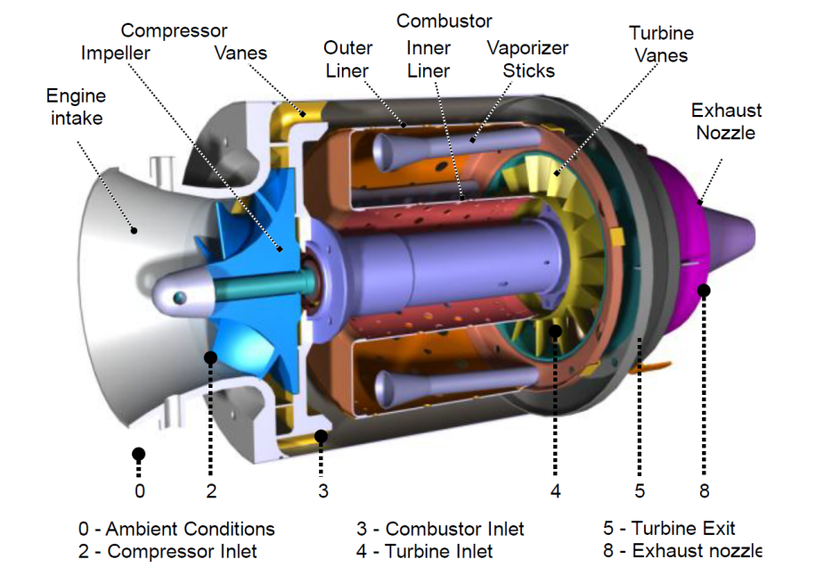

This is final chosen design
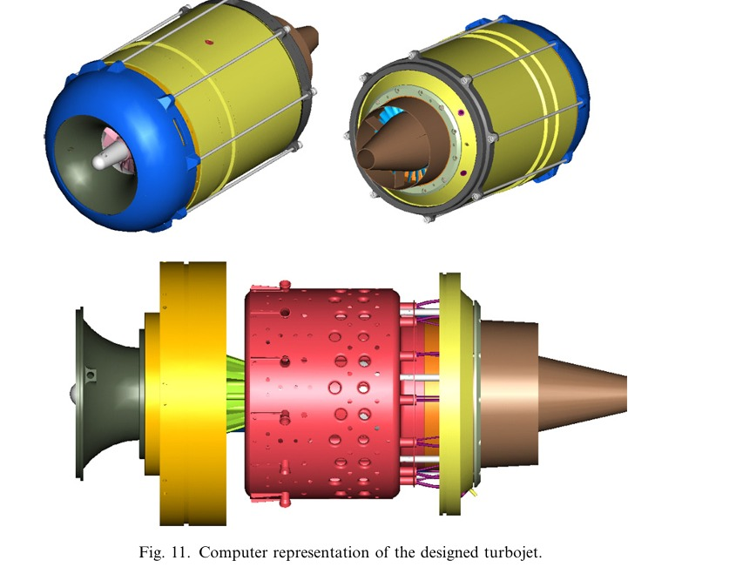
Design two using an diffuser behind the impeller and converging it behind the compressor ?
Or sort of ?
This doesn’t seem like that , it seems like the green one is just the structural connection between combustion chamber and compresser
And out of all the model I saw,
The combustion chamber has significant gap between compressor , this should be definitelyn done to prevent the heat ,
We can additionally add a diverging duct to further increase the pressure but the entire combustion chamber should be sealed to retain the pressure ,., “ O- rings to but “
And no hole in front of combustion chamber or holes with less dia , acc to design and combustion ratio ,
Maybe we need to get a simple turbine which can be cnc machined to achieve some meaningful cycle close to jet engines.
The annular diffuser just behind the compresser
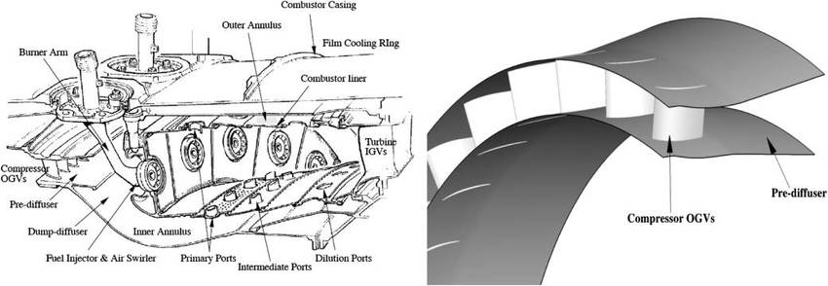

Continues at first page ……………………………………………………………………………………………..

